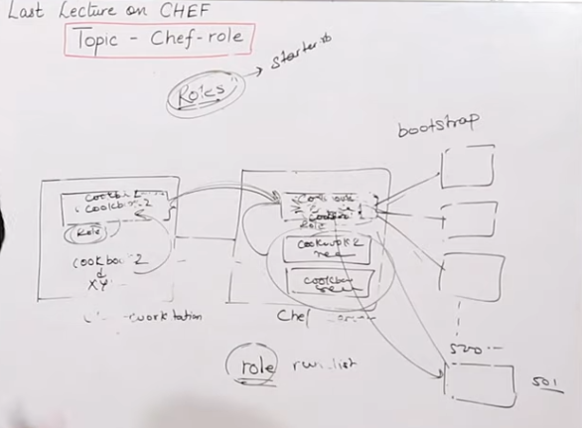

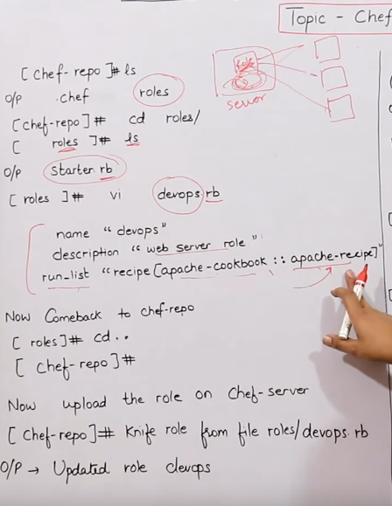

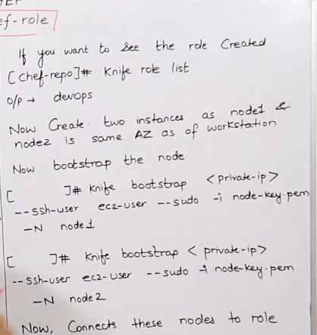

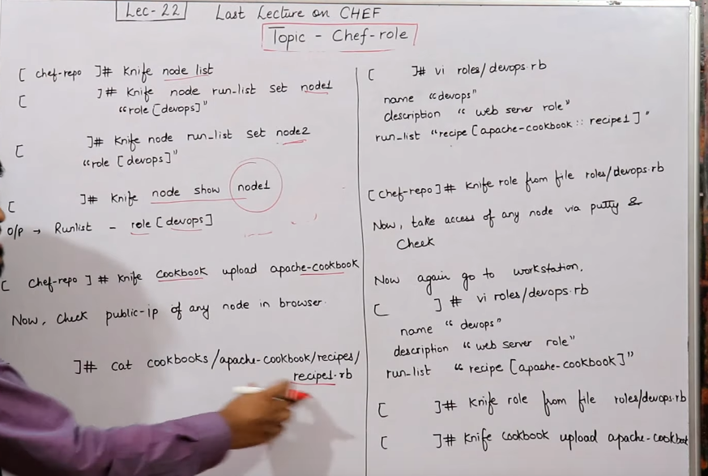

Two appach cook book test cook book

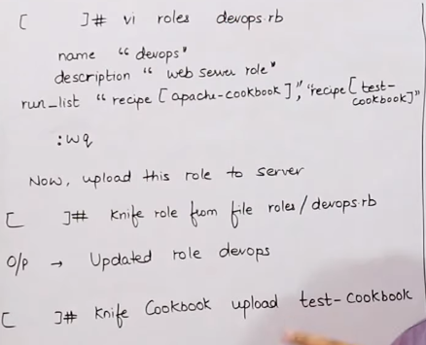

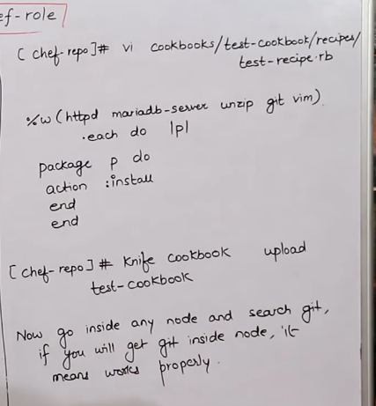

Roles

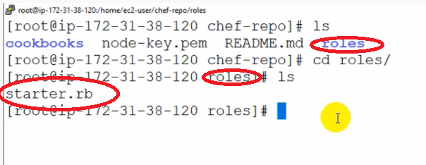

Create a new roles name of devops.rb

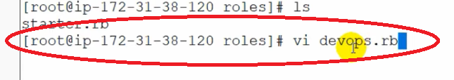

Vi editer code

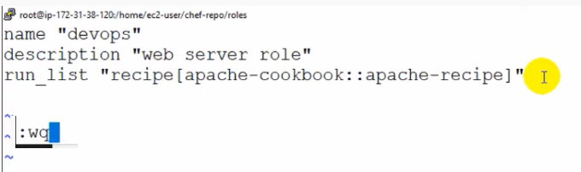

To check the ls command (it will chow the name what we created name of devops)

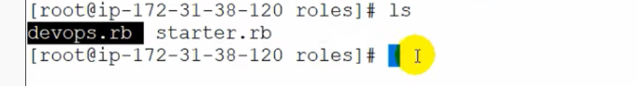

Roles to be update

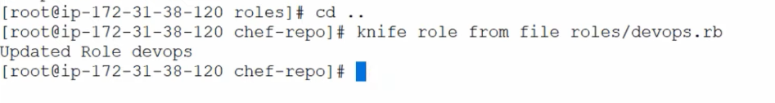

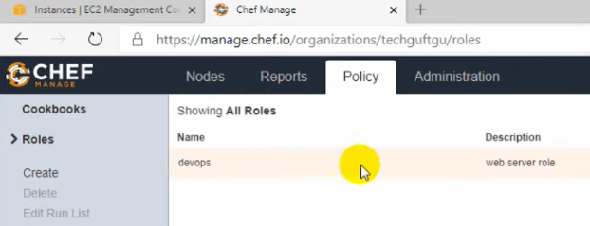

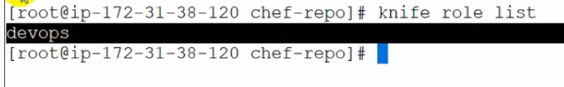

Number of notes to be creates in ASW (4 Client System)

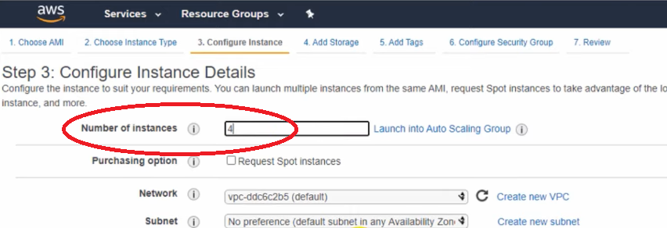

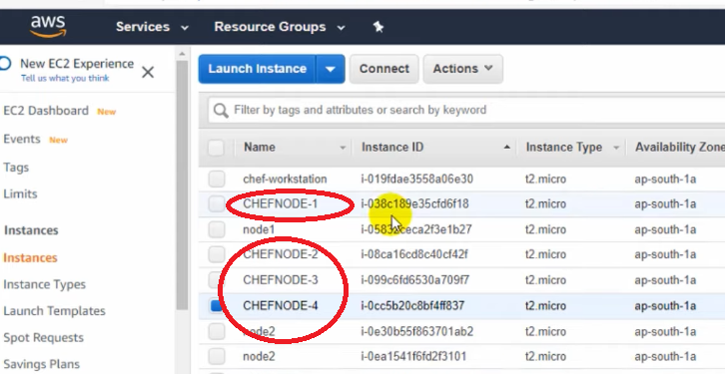

Type a node one IP add in the give command (like this 4 IP shod be add in this command)

1

2



3



4



To see the node type give command (Knife node list)

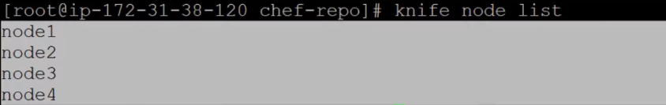

URL server

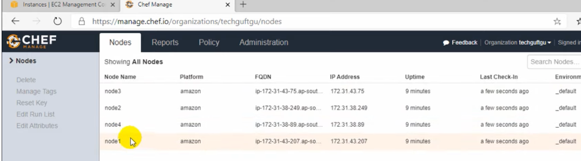

Add the node in roles we cared name in devops

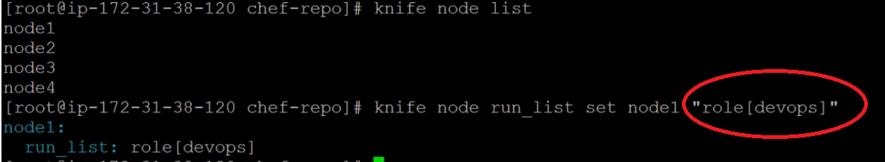

Like this four note to be add in roles (name of devops )

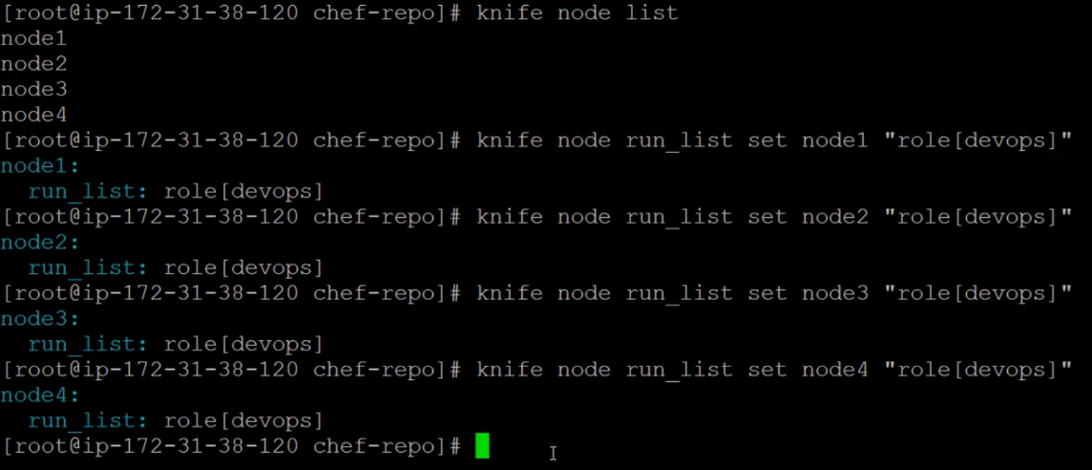

Show node 1 command in connected in roles

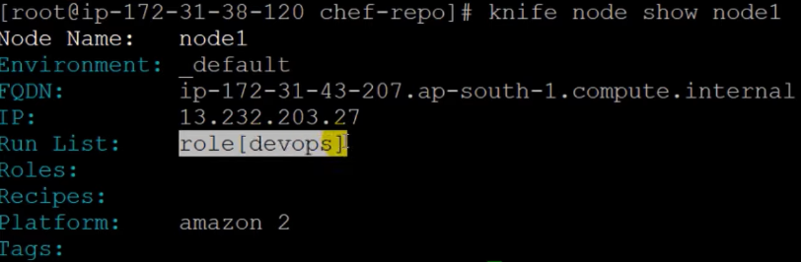

Edit run list it will show the role in devops

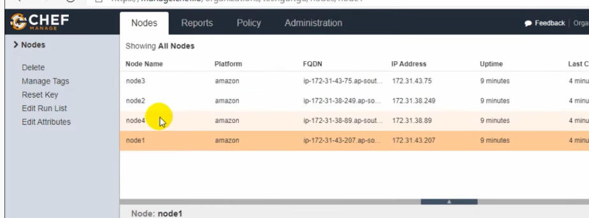

Upload the apache server



Vi editor to see a code



Editer page

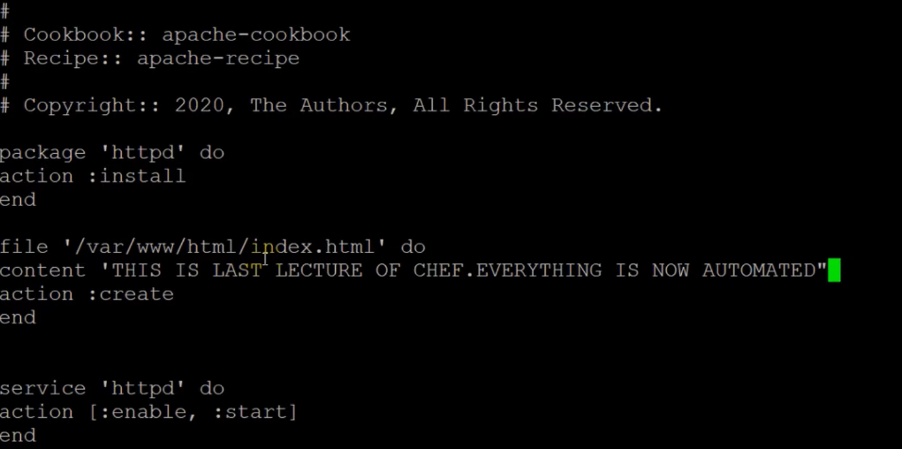

Save :wq

Now I can upload the file in give command



Now you can check the IP address in URL will be update in editor

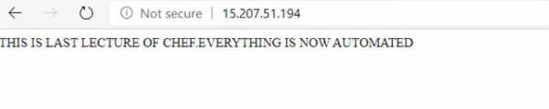

Boss told to working in recipe3

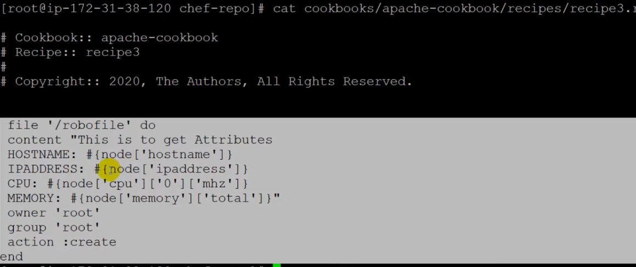

Now go to vi editor recipe3



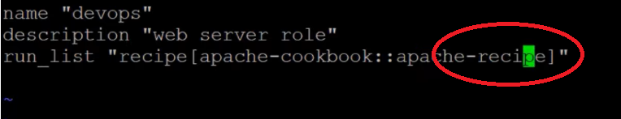

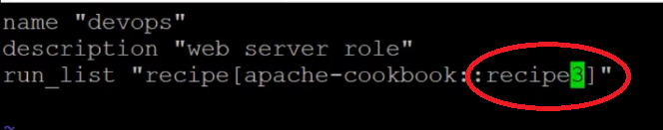

Save and exit :wq



Node 3 update out put

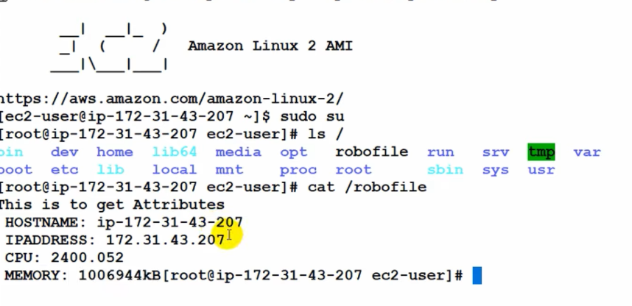



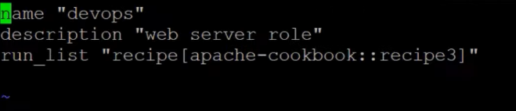

What are the recipes in apache –cookbook every think will be update

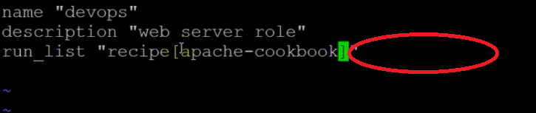

Upload it



Now I can edit recipe 3



Recipe 3 I add the user name and file .

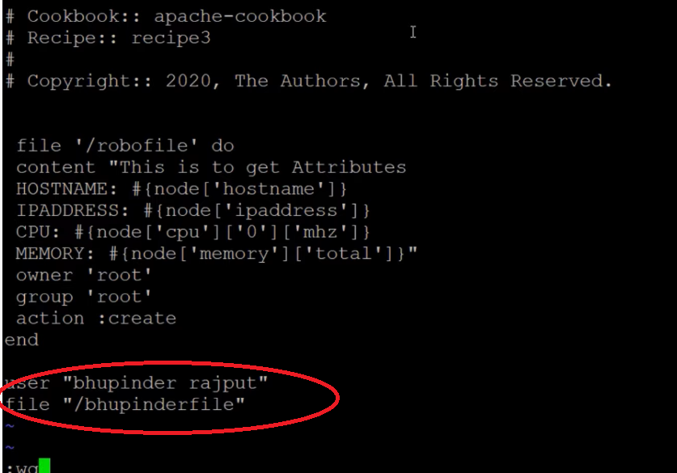

Edit in recipe 3 and apache also



Upload it



What to add two cookbook



Am working in two cookbook so add the roles in two cookbook (aapache & test) cookbook

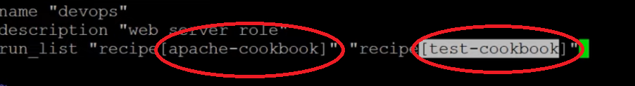

Upload it

